# **Phase 4 – Validation Rules, Workflows, Email Templates, and Custom Fields**

**Project:** Student Enrollment & Engagement CRM  
 **Author:** Samyak Badkul  
 **Date:** [Insert Date]

## **Objective**

Ensure data integrity and automate basic student engagement processes using **validation rules, workflow rules, email templates, and custom fields**.

## **Items Implemented in Phase 4**

### **1. Validation Rules**

* **ValidationRule_RequireEmail**
  + Ensures the Email field is mandatory for all student records.
  + Prevents records from being saved without a valid email.
  + **Screenshot:** 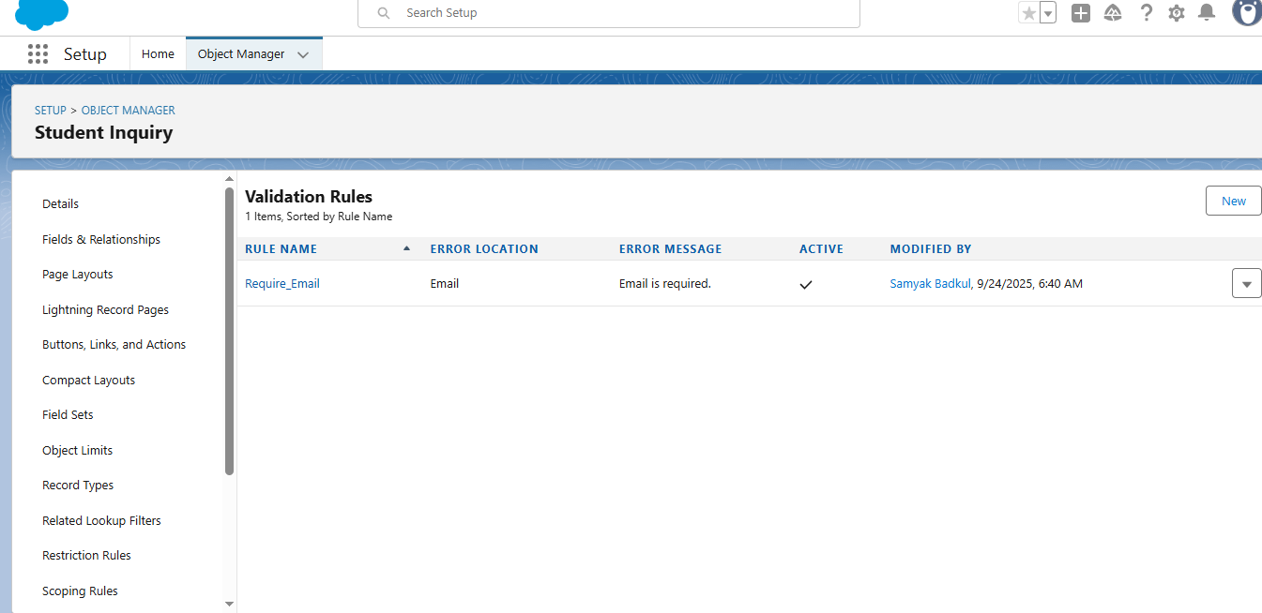
* **ValidationRule_AppDate**
  + Ensures that the Application Date is valid and not a future date.
  + Prevents incorrect application data entry.
  + **Screenshot:** 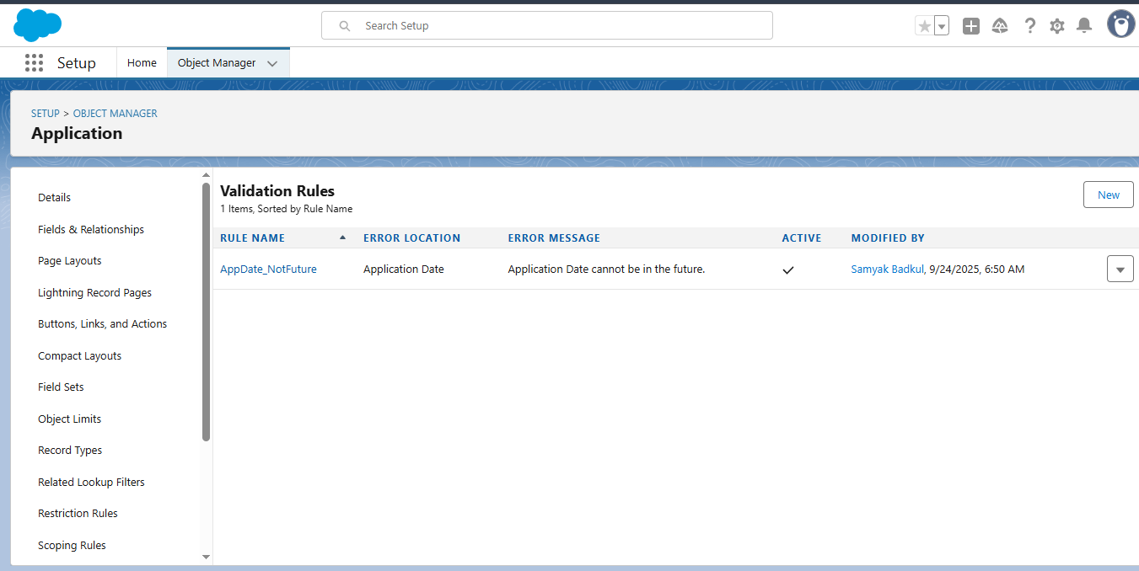

### **2. Email Automation**

* **EmailTemplate_InquiryAssigned**
  + Template for sending notifications when a new inquiry is assigned to a counselor.
  + Contains student name, inquiry details, and assigned counselor info.
  + **Screenshot:** 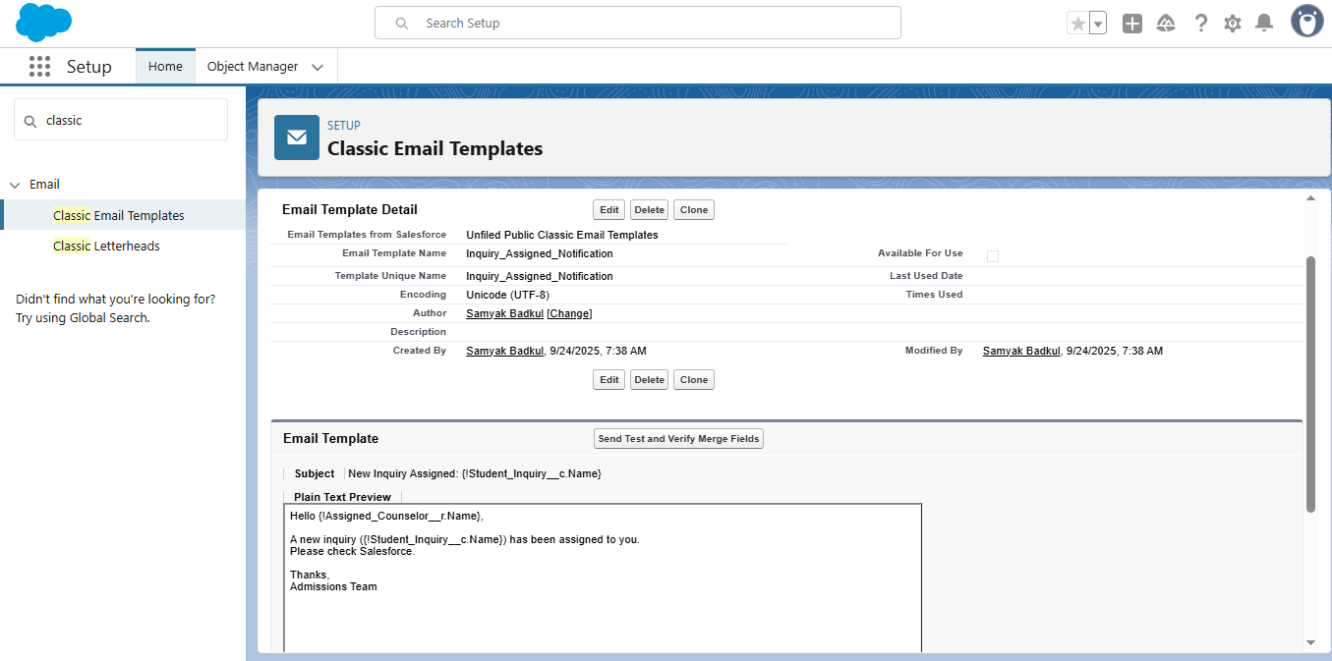
* **EmailAlert_InquiryAssigned**
  + Linked to the above email template.
  + Automatically triggers email when workflow conditions are met.
  + **Screenshot:**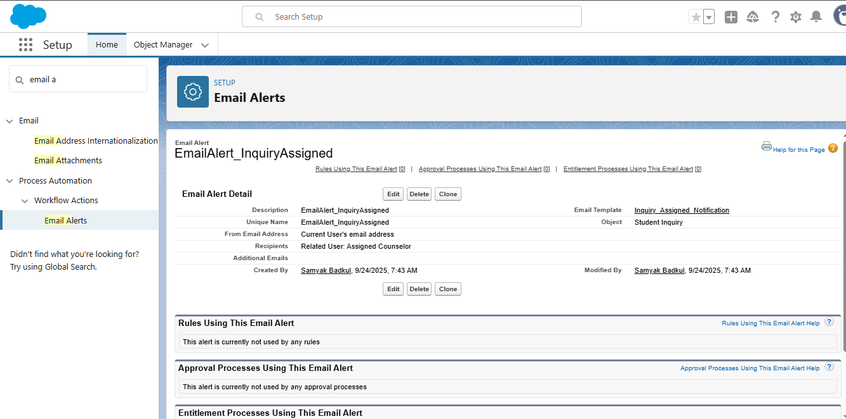
* **WorkflowRule_InquiryAssigned**
  + Workflow that triggers the above email alert.
  + Condition: When a new inquiry is assigned to a counselor.
  + **Screenshot:**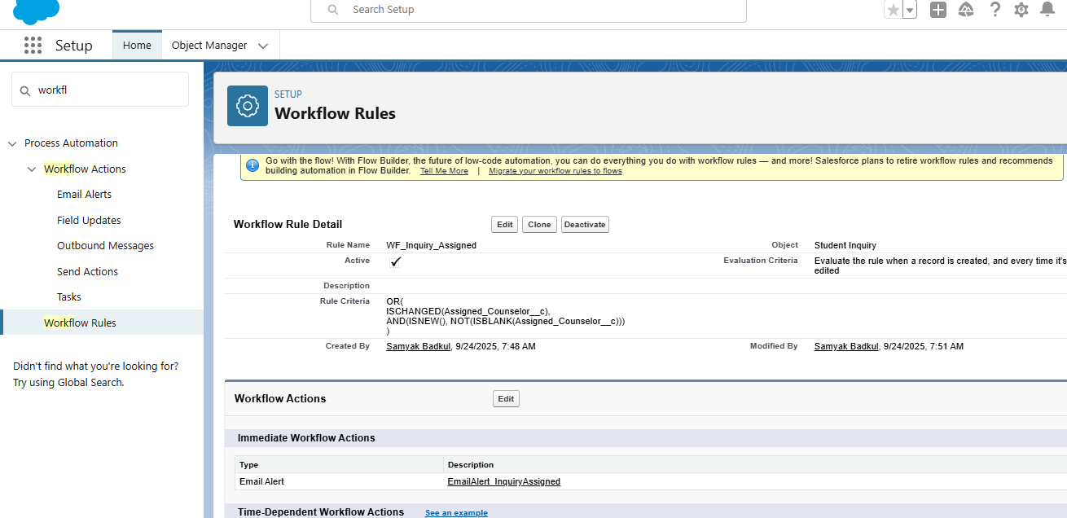

### **3. Custom Fields**

* **Application_ScholarshipField**
  + Tracks whether a student has applied for a scholarship.
  + Used for reporting and future automation.
  + **Screenshot:**  
    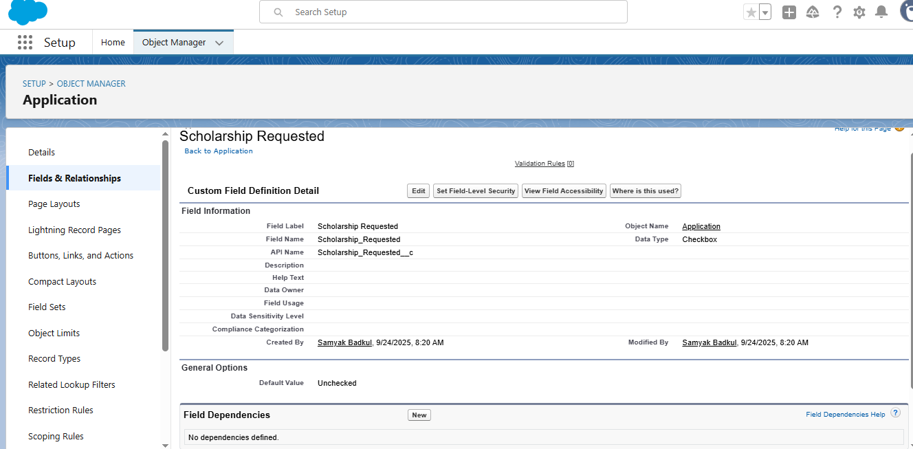

## **Testing**

* Created **test student records** to verify:  
  1. Validation rules trigger correctly for missing email or invalid application date.
  2. Workflow sends email to assigned counselor when a new inquiry is created.
  3. Custom fields are visible and correctly populated.
* All items functioned as expected.

## **Notes**

* Optional automation steps like:  
  + **Flow – Auto-Create Enrollment When Application Accepted**
  + **Approval Process – Scholarship Requests** **were skipped** and are not required for project progress.